|  |
| --- |
| **MINISTRY OF EDUCATION AND TRAINING** |
| **FPT UniverSITY** |

Capstone Project Document

|  |
| --- |
| [Ordering Application by Location] |
|  |
| |  |  | | --- | --- | | **<>** | | | **Group Members** | <Nguyễn Quốc Đạt><SE04036><datnqse04036>  <Nguyễn Đại Thắng><SE04441><thangndse04441>  <Ngô Ngọc Tuyên><SE04335 ><tuyennnse04335>  <Mai Gia Tú><SE04012>< tumgse04012>  <Vũ Sỹ Tùng><SE04113><tungvsse04113> | | **Supervisor** | Lương Trung Kiên | | **Ext Supervisor** |  | | **Capstone Project code** | OAL | |

**Ha Noi, 0****5/2018**

# Introduction

## Purpose

Introduction chapter introduces the background and initial idea of the Capstone Project. In this chapter, we – the developing team – will provide information about what we do, the reason why we do.

By comparing to the similar existing solutions, we also shows advantages, benefits, limitation and risks that our system has to face up to in the future.

## Project Information

|  |  |
| --- | --- |
| Project Name | Ordering Application by Location |
| Project Code | OAL |
| Project Category | Development |
| Application Type | Application and Website |
| Timeline | From May 2018 to Sep 2018 |

## Team information

### Supervisor

|  |  |  |  |
| --- | --- | --- | --- |
| **Full Name** | **Phone** | **E-mail** | **Title** |
| Lương Trung Kiên | 0983357211 | [kienlt@fpt.edu.vn](mailto:kienlt@fpt.edu.vn) | Lecturer |

**Table 1-1**: Supervisor information

### Team members

|  |  |  |  |  |  |
| --- | --- | --- | --- | --- | --- |
| **No.** | **Full Name** | **Roll Number** | **Phone** | **E-mail** | **Role in Group** |
| 1 | Nguyễn Quốc Đạt | SE04036 | 0942281296 | [datnqse04036@fpt.edu.vn](mailto:datnqse04036@fpt.edu.vn) | Team Leader |
| 2 | Ngô Ngọc Tuyên | SE04335 | 0964346976 | tuyennnse04335[@fpt.edu.vn](mailto:KhoaNDSE60811@fpt.edu.vn) | Member |
| 3 | Nguyễn Đại Thắng | SE04441 | 01686396395 | thangndse04441[@fpt.edu.vn](mailto:OwokonuSE04494@fpt.edu.vn) | Member |
| 4 | Mai Gia Tú | SE04012 | 0972678655 | tumgse04012[@fpt.edu.vn](mailto:ManhPHSE06191@fpt.edu.vn) | Member |
| 5 | Vũ Sỹ Tùng | SE04113 | 0916606094 | tungvsse04113[@fpt.edu.vn](mailto:ManhPHSE06191@fpt.edu.vn) | Member |

**Table 1-2:**Team’s members information

## Background

Nowadays, Viet Nam becomes one of the fastest growing Internet applications countries in the world. Number of Viet Nam Internet user is 58 million, ranked No.1 in ASEAN on number of national domain name, ranked No.30 worldwide on number of IPV4 address. But, Internet in Viet Nam is grown unevenly, fast develop in big city, exactly, Ha Noi and Ho Chi Minh, and slowly develop in other cities.

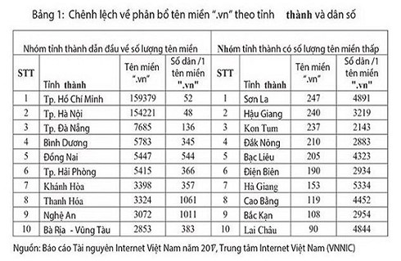

*Nowadays,* as analysis, as Vietnam E-commerce Association, Vietnam's e-commerce growth rate in 2017 is 25 percent and this rate can increase in period 2018-2020. As “We are social” website, mobile connection rate in Viet Nam is 153% as total population in 2017. 73% of Vietnamese have unique mobile, as well as, 50% Vietnamese use mobile social. In Viet Nam, number of grocery is continuous increase, almost of it is owner grocery. So online shopping has not completely replaced private grocery yet. In the other hand, 47% digital user buy products via her/his smartphone in Dec,2017. For which, 16% Vietnamese phone user search for contents based on location on his/her smartphone. So, there is no e-commerce shopping application/website allow user can search products/store based on user’s current location.

TOTAL
POPULATION
INTERNET
USERS
ACTIVE SOCIAL
MEDIA USERS
UNIQUE
MOBILE USERS
ACTIVE MOBILE
SOCIAL USERS
JAN
2018 A SNAPSH...

**Statistics data on digital trends in Vietnam in 2017 (Source :** **wearesocial.com)**

37
NUMBER OF UNIQUE
MOBILE USERS (ANY
TYPE OF HANDSET)
MOBILE PENETRATION
(UNIQUE USERS vs.
TOTAL POPULATION)
TOTAL NUMBER...

**Statistics data on phone and telephone connection in Vietnam in 2017**

**(Source :** **wearesocial.com)**

44
SEARCHED ONLINE
FOR A PRODUCT
OR SERVICE TOBUY
VISITED
ANONLINE
RETAIL STORE
PURCHASED A
PRODUCT OR
SERVICE ONLINE
MADE...

**Statistics on online shopping trends in Vietnam in December 2017 (Source :** **wearesocial.com)**

As Director of Consumer Behaviour Research of Nielsen INC, e-commerce in Vietnam has not reached the expected due to user concerned about the quality of goods, long shipment time,..

E-commerce shopping has some advantages are convenient, every-when-buying, easy payment. But, it also has many disadvantages hard to check product’s quality, hard to check store’s service, long shipment time, so on.

## The capstone aim

The aim of this capstone project is to design and develop an E- Shopping Application, on which End-user can search for products such as housewares, customer goods, electronics, ... and order it through nearby store related to their current location. The store can not only add new products, remove and change price and promotion of products, but also to accept or to decline the ordering.

## Literature review of existing system

### Name of current system

* Shopee: a shopping application which belongs to Garena – a consumer Internet platform provider based in Asia. This application allows user register virtual store in system. The end-user not only can search so many kinds of product through Search box or category, but also to order these products through registered virtual store.
* Lazada: a shopping application which belongs to Alibaba – one of top 10 most valuable and biggest companies in the world. This application allows end-user search products, view products as category, order products through before-registered virtual stores.
* Groupon: an electronic commerce shopping application which belongs to Groupon Inc. This application has same basic function as other e- commerce shopping applications such as: search products, order products, register store, …. Groupon app, in other hand, have a unique function which is locate nearby store to user’s current location.

### Strength of existing system

1. *Shopee*
   * Large community.
   * Colourful, nice user-interface, great user-experience.
   * Promotion programs are usually, attractive.
   * Support website platform.
   * User can comment, rate and report to virtual stores.
2. *Lazada*
   * Large community.
   * Nice user-interface, great user-experience.
   * Promotion programs are usually, attractive.
   * Support website platform.
   * User can comment, rate and report to virtual stores.
   * Have some kinds of genuine.
3. *Groupon*
   * Colourful, nice user-interface, great user-experience.
   * Promotion programs are usually, attractive.
   * Support website platform.
   * Unique function: locate nearby store to user’s current location.

### Weakness of existing system

1. *Shopee*
   * Management virtual store is hard.
   * Sources of product are uncensored.
   * Shipment time is usually long.
   * Hard to find nearby stores to user’s current location.
2. *Lazada*
   * Management virtual store is hard.
   * Sources of product are uncensored.
   * Shipment time is usually long.
   * Hard to find nearby stores to user’s current location.
3. *Groupon*
   * User cannot report to virtual stores.
   * Application do not work in Viet Nam

### 1.6.4 To acquire knowledge

1. *Shopee + Lazada*

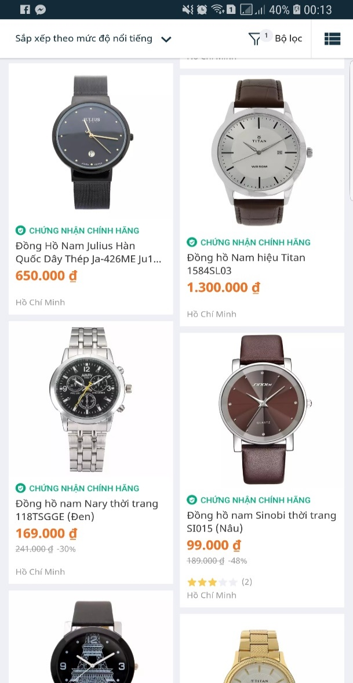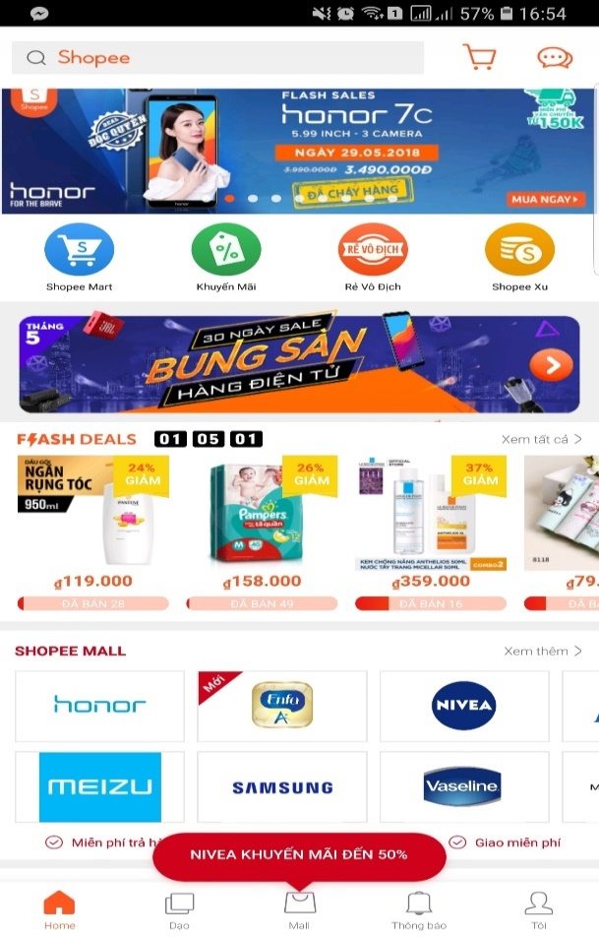

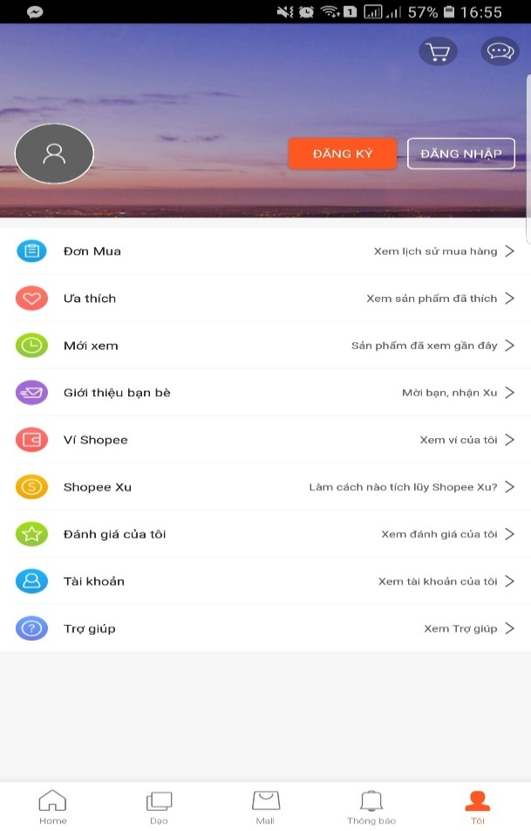

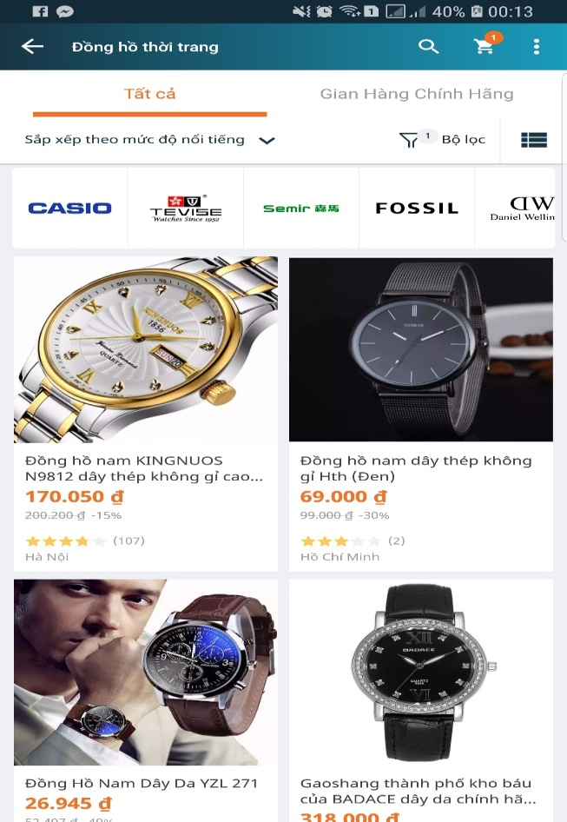

We can learn more from user-interface; how to arrange components in application screen; how ordering business works; how to display products, categories, product details in colorful, clearly layout.

1. *Grab*

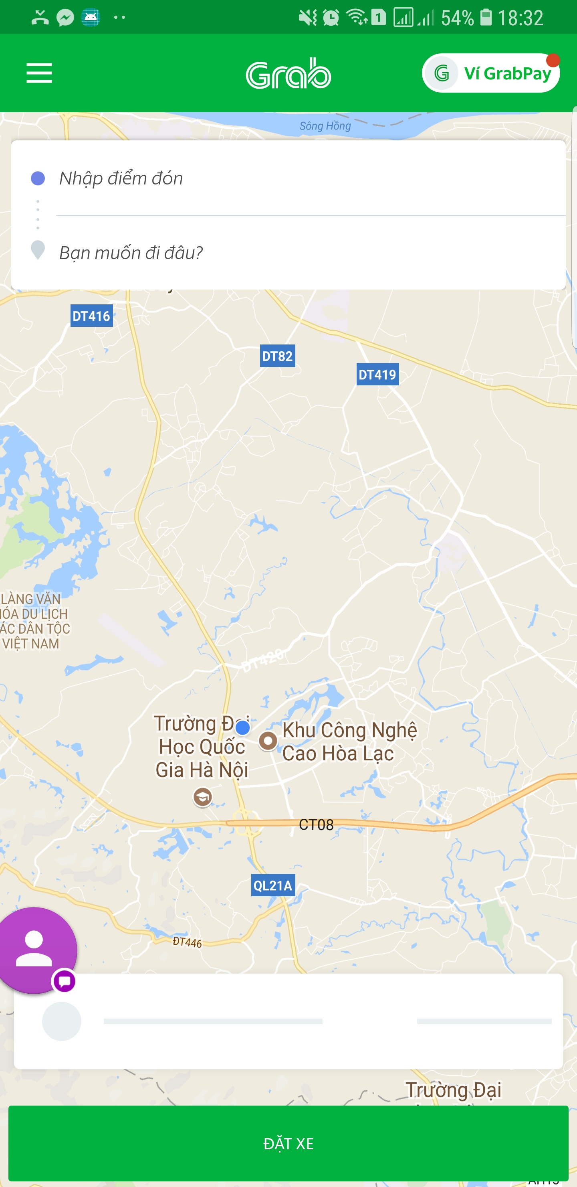

We have learned how the application locate user’s current location, how application identify nearby target to user’s current location in local map, how application direct the way to target.

1. *Groupon (Website version)*

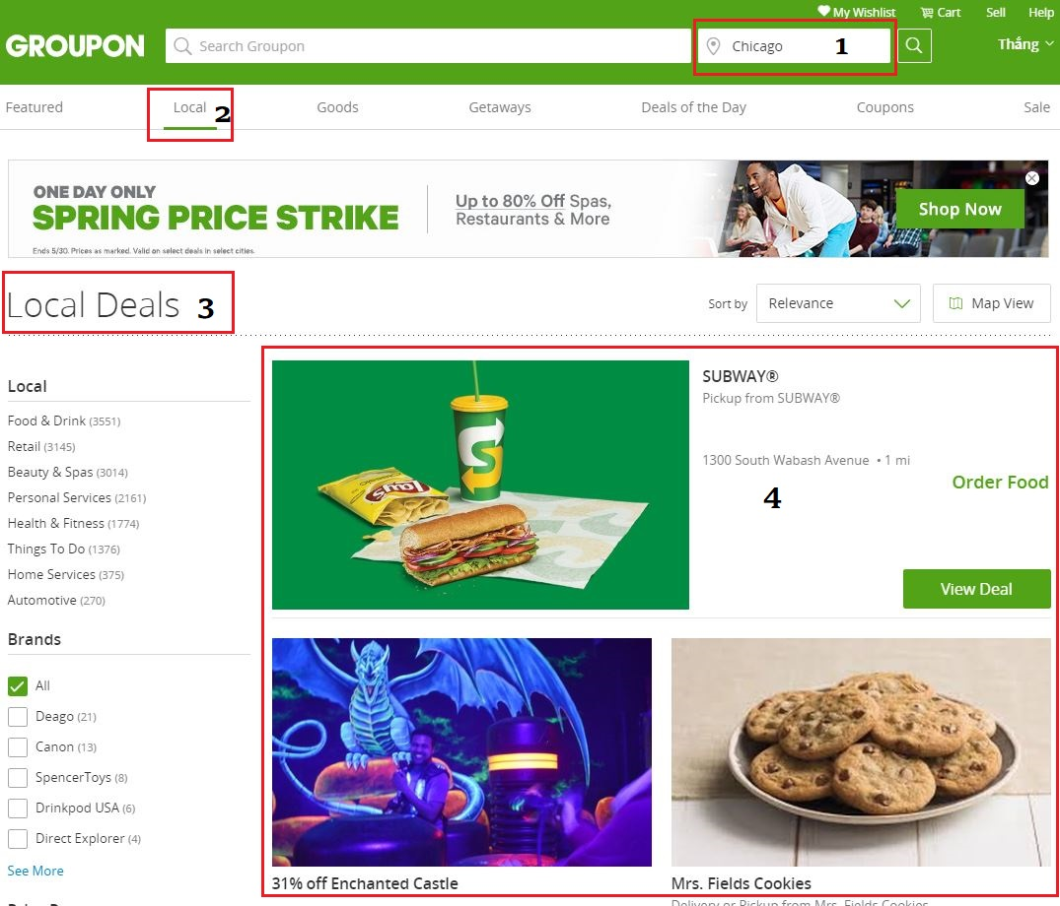We have learned how the application identify nearby target deals to current chosen place (location), how the application identifies chosen place (location).

## Our Proposal

### Situation

* Nam is a high-school student in Hung Yen. This May, he would take part in FPT University entrance exam in Ha Noi. So, he decided to arrive to Ha Noi 1 day early to visit Ho Chi Minh museum, Lotte building,..
* After visiting Ho Chi Minh museum, Nam had arrived to Lotte building and he felt thirsty. He decided to find a grocery or mini mart to buy a beverage bottle and an ice-cream but he couldn’t. He had walked all the Chua Mot Cot Street, he saw fashion shops, souvenir shops, restaurants but no grocery. Then, he tried to walk all the Dien Bien Street and he got same result.
* This is a typical situation which indicates difficulty in finding grocery or mini mart on strange place where users haven’t even arrived.
* 3S will help finding grocery becomes easy.

### Ideas

* To support end-user can find nearest store to order products.
* To minimize product delivery time to end-user.
* Remove direct payment because the development time is limit. In the other hand, the application finds nearby store which have user-needed-products to recommend so the distance between end-user and store is usually short. Recommend to use COD payment.
* To support end-user can find nearby store to user’s current location, in case, user have arrived to strange place (location).

### Advantages

* Easy to search (find) products which they need.
* Easy to order products through nearby store to their current location.
* Easy to register store, but this registration will be close censored.
* Convenient to find nearby store address to user’s current location when user have arrived strange place.

### Disadvantages

* To not have directly online payment yet.
* Hard to control spam ordering (in case, after sending ordering product, end-user cancel these ordering).

### Expectation

* To have a platform to connect stores with users
* To make user convenient, happy in buying products.
* To make store easy to advertise, approach to user.

# Software Project Management Plan(SPMP)

## Problem Definition

### Name of this capstone project

* + This capstone project is a system which includes a mobile application and a website. This system has been named “5SAO” which means “5 Super Application of Ordering”
    - Super-Fast
    - Super-Convenient
    - Super-Saving
    - Super Professional
    - Super Friendly

### Project Abstract

* + Nowadays, e-commerce, specifically, e-shopping application becomes more popular. Everyone can approach, search and ordering products via

e-shopping application. But, we realize that we have a trouble which end-users are hard to approach to nearby stores. They usually search products and order these via system-suggested stories which maybe is so far away from them. This can make deliverable time so long.

* + We create a system via locating user’s current location or chosen location to help users decrease deliverable time. This system is useful for people who had arrived to strange place/location.

### Project Overview

1. *The Current System*
2. *The Proposed System*

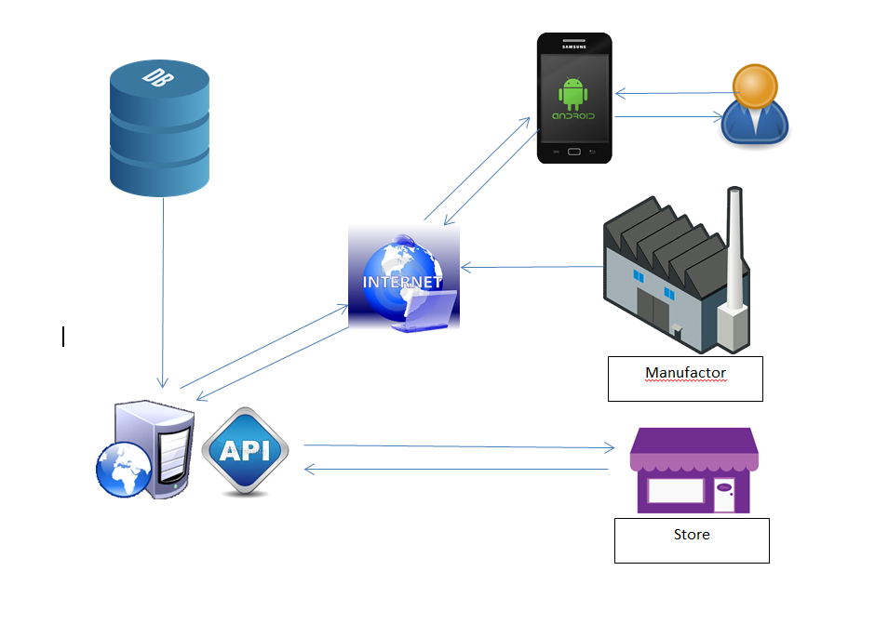

1. *Boundaries of the System*
2. *Development Environment*
   * **JDK 1.8**: The Java Development Kit (JDK) is a software development environment used for developing Java applications and applets. It includes the Java Runtime Environment (JRE), an interpreter/loader (java), a compiler (javac), an archiver (jar), a documentation generator (javadoc) and other tools needed in Java development.
   * **NetBeans IDE 8.2**: An integrated development environment (IDE) for Java
   * **Android SDK (software development kit):** A set of development tools used to develop applications for Android platform. The Android SDK includes the following:
     + Required libraries
     + Debugger
     + An emulator
     + Relevant documentation for the Android application program interfaces (APIs)
     + Sample source code
     + Tutorials for the Android OS
   * **Android Studio 3.1.2**: The official Integrated Development Environment (IDE) for Android app development
   * **Server CentOS 7:** An operating system for server
   * **Tomcat 7.0.76**: An open source implementation of the Java Servlet, Java Server Pages, Java Expression Language and Java Web Socket technologies.
   * **MySQL**: An open-source relational database management system (RDBMS)

## Project Organization

### Project Process Model

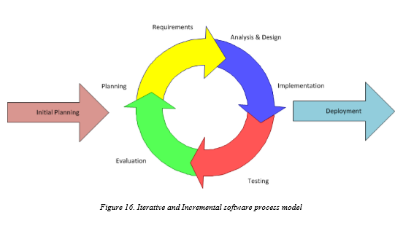

5SAO uses Iterative and Incremental software process model – a method by which system is developed in small phases in a time and through repeated cycles. Developers can take advantage of this model through reviewing parts of system to change or improve them. It also allows developers to receive feedback to modify the target of the next releases.

During the time of doing Capstone project, we divide the process into 2 iterations. Detail information about the iterations is explained in the part of Project management plan.

### Organization Structure

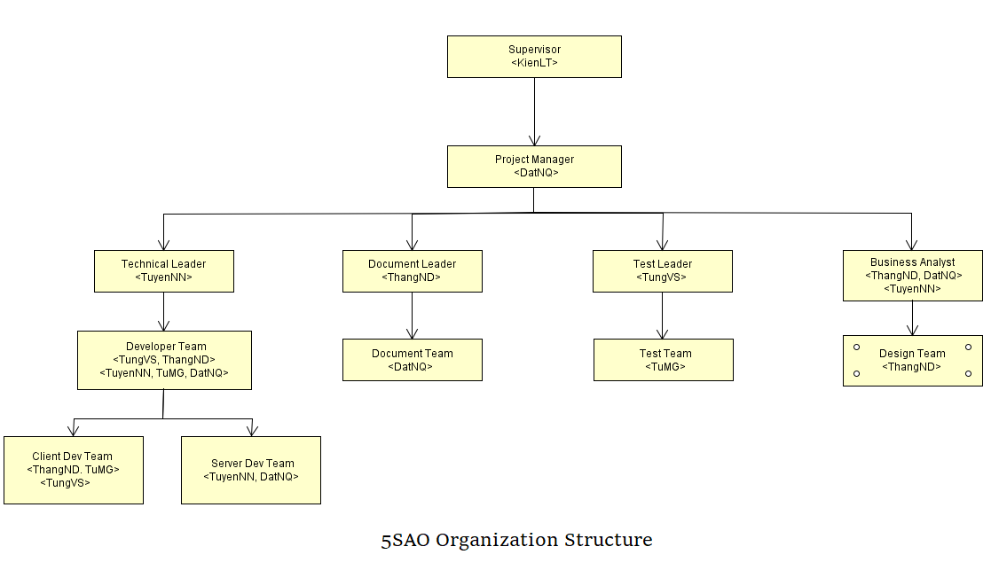

### Organization Structure

|  |  |
| --- | --- |
| **Role** | **Responsibility** |
| Project manager | Project manager has responsibilities to plan, schedule and control the project. He has to communicate with all teams to keep them focusing on the final goal also. |
| Technical leader | Technical leader has responsibilities to decide what technologies the project uses. He works with business analysts to design system architecture and database. Additionally, he supervises other developers working |
| Document leader | Document leader has responsibility to prepare all the documents relating to the project. |
| Test leader | Test leader has responsibilities to plan, monitor and control the testing activities and tasks, including setting up test, evaluating test run and recording test results. |
| Developer | Developers have responsibilities to code product, review other developers’ code. They set up, run unit test, receive bugs from testers and fix these bugs. |
| Tester | Testers have responsibilities to test product, write test cases for integration, regression and acceptance test phases. They execute these written test cases, log bugs and inform developers |
| Designer | Designer has responsibilities to design user interface of product, draw mock-up screens for all user cases before implementing |
| Business analyst | Business analysts have responsibilities to work with project manager to analyse business domain, define functions and scope of system. They work as a bridge between business problems and technology solutions. |

### Project Team Member

|  |  |
| --- | --- |
| **Team member** | **Role** |
| DatNQ | Project manager, Developer, Business Analyst |
| TuyenNN | Technical leader, Developer, Business Analyst |
| ThangND | Document Leader, Developer, Business Analyst, Designer |
| TungVS | Test Leader, Developer, Tester |
| TuMG | Developer, Tester |

### Tools

|  |  |
| --- | --- |
| **UML tool** | Astah |
| **Project management tools** | Trello, Microsoft Project Management |
| **Process model** | Iterative and Incremental software process model. |
| **Drawing mock-up tool** | Fluid UI |
| **API Development Environment** | Postman |

## Project Management Plan

### Tasks schedule

* + Iteration 1: Focusing on developing document,design and basic functions
    - Duration: May, 15th 2018 – June, 24th 2018.
    - Content:
      * Identifying group, members and analyzing requirements.
      * Designing, executing and testing basic functions such as: login, register, search products, order products, add products to store,...
      * Do reports.
      * Defining figures of specification about performance (memory, delay time, load time…).
      * Deployment and closing.
  + Iteration 2: Focusing on developing advance functions
    - Duration: June, 25st 2018 – August, 5th 2018.
    - Content:
      * Completing basic functions.
      * Designing, executing and testing advance functions.
      * Continue doing reports.
      * Defining figures of specification about performance (memory, delay time, load time…).
      * Deployment.
  + Iteration 3: Focusing on fix bug and optimize application
    - Duration: August, 6th 2018 – August, 31st 2018.
    - Content:
      * Completing advance functions.
      * Fix bug
      * Optimize code and application performent.
      * Finish reports.
      * Deployment.
      * Relax

### Project milestones

|  |  |  |  |
| --- | --- | --- | --- |
| **No** | **Milestone** | **Completion Date** | **Verification** |
| 1 | Project start | 14/05/2018 | Supervisor |
| 2 | Submit report 1 | 04/06/2018 | Supervisor |
| 3 | Submit report 2 | 11/06/2018 | Supervisor |
| 4 | Submit report 3 | 18/06/2018 | Supervisor |
| 5 | Submit report 4 | 25/06/2018 | Supervisor |
| 6 | Submit report 5 | 09/07/2018 | Supervisor |
| 7 | Submit report 6 | 23/07/2018 | Supervisor |
| 8 | Final report | 20/08/2018 | FPT University, Supervisor |
| 9 | Defend project | ……. | FPT University, Supervisor |

### Meeting Minutes

A secretary whom the project manager assigns to will note all the meetings of team. He or she should write down ideas, contents discussion and notation by following the meeting minutes form below:

|  |  |  |  |
| --- | --- | --- | --- |
| ***Meeting/Project Name:*** |  | | |
| ***Date of Meeting:*** |  | ***Time: (Type)*** |  |
| ***Meeting Called by:*** |  | ***Location:*** |  |
| ***Note Taker:*** |  | ***Time Keeper:*** |  |
| 1. **Meeting Objective**   *<General description about meeting>*  Example:  -Introducing team members  - Setting up working rules  - Choosing name, raising ideas for project  - Other information | | | |
| 1. **Attendance**  |  |  |  |  | | --- | --- | --- | --- | | ***Member*** | ***Roles*** | ***E-mail*** | ***Attendance*** | | Nguyễn Quốc Đạt | PM, Technical Leader, BA | [datnqse04036@fpt.edu.vn](mailto:datnqse04036@fpt.edu.vn) |  | | Nguyễn Đại Thắng | Developer, Designer | [thangnd04441@fpt.edu.vn](mailto:thangnd04441@fpt.edu.vn) |  | | Ngô Ngọc Tuyên | Developer, Tester, BA | [tuyennnse04335@fpt.edu.vn](mailto:tuyennnse04335@fpt.edu.vn) |  | | Mai Gia Tú | Developer, Tester, BA | [tumgse04012@fpt.edu.vn](mailto:tumgse04012@fpt.edu.vn) |  | | Vũ Sỹ Tùng | Developer, Tester | [tungvsse04113@fpt.edu.vn](mailto:tungvsse04113@fpt.edu.vn) |  | | | | |
| 1. **Content**   **……………………………………………………….……………………………………………………….**  **……………………………………………………….……………………………………………………….**  **……………………………………………………….……………………………………………………….**  **……………………………………………………….……………………………………………………….** | | | |
| 1. **Note**   **……………………………………………………….……………………………………………………….**  **……………………………………………………….……………………………………………………….**  **……………………………………………………….……………………………………………………….**  **……………………………………………………….……………………………………………………….** | | | |

### Coding Convention

* + Purpose of coding conventions:
    - Coding conventions create a consistent look to the code. They help readers to focus on content, not layout.
    - Coding conventions enable readers to quickly understand by making assumptions based on previous experiences.
    - Coding conventions facilitate copying, changing and maintaining the code.
  + Because of these reasons, we strictly follow the Convention Styles Guide below:
    - Android SDK :
      * Coding Style : <https://source.android.com/setup/contribute/code-style>
      * Project guidelines:

<https://github.com/ribot/android-guidelines/blob/master/project_and_code_guidelines.md>

XML Naming Convention: <https://jeroenmols.com/blog/2016/03/07/resourcenaming/>

* + - Java Spring:

<https://docs.spring.io/spring/docs/current/javadoc-api/org/springframework/core/Conventions.html>

### Risk management

|  |  |  |  |  |
| --- | --- | --- | --- | --- |
| **No** | **Description** | **Avoidance plan** | **Contingency plan** | **Impact** |
| R1 | Absence/illness of team members | Members have inform the project manager the reason why they are absent and build their own plan to keep up with the work process. | The project manager always has back up plan to avoid effect from the absence and ensure that problem will be solved | High |
| R2 | Conflicts among members | At the beginning, members should clear their roles and responsibilities. | The project manager has to find out the root that caused problem and solve it. Face-to-face meeting is a good method | Medium |
| R3 | Project team member misunderstands requirements | Members have to read requirement specification and related documents carefully. | Making sure that any miscommunication would be resolved. | Medium |
| R4 | Equipment of members is broken. | Members must be careful with their equipment. | Members should use another equipment until the broken one is fixed or buy the new one. | Low |
| R5 | Business problem | Any ideas are welcome but members have to discuss with others and always focus on the reality and possibility. | Making sure that the business logic of any ideas is carefully analyzed. | High |
| R6 | New technologies | Choosing technology based on members’ qualification. All team members must nurture by self-study. | When the technical leader chooses a new technology, he has to explain to all team members about the decision. | High |
| R7 | Lack of knowledge and experiences about source code management |  |  |  |